1. General information

* Main color: #bec913

1. Detail
2. Splash Screen



1. Main Screen

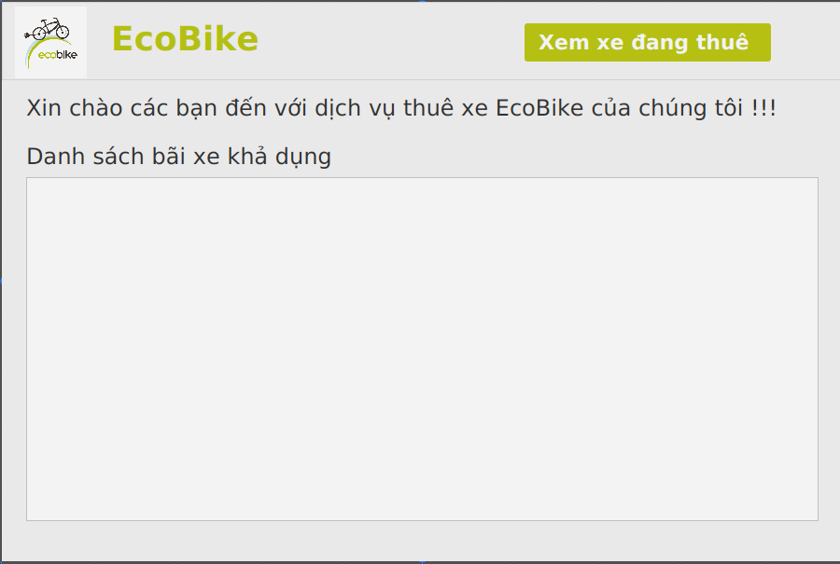

* Function: Home screen of application
* Contain:
* Logo
* Name: EcoBike
* Button “Xem xe đang thuê”: Show Rented Bike Info Screen when you click
* List of available station:
* show all station by row but unavailable station information is lighter in color
* show Station Screen when you click one available station

1. Station Screen

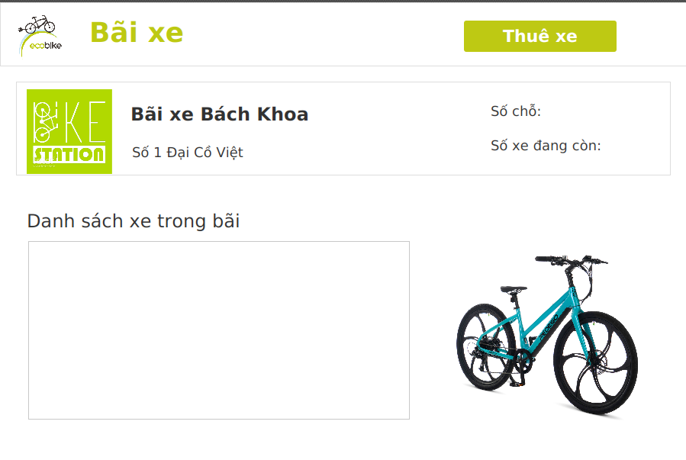

* Precondition: You click one station in Main Screen
* Function: Show information of station
* Contain:
* Logo
* Name: Bãi xe
* Button “Thuê xe”: Show Rent Bike Screen when you click
* Information of station:
* Logo of station:
* Name of station: Bãi xe Bách Khoa
* Address of station: số 1 Đại Cồ Việt
* Number of slots:
* Number of available bike:
* List of available bike:
* show all bike by row but unavailable bike information is lighter in color
* show Detail Bike Screen when you double click one bike
* change BIke image when you choose one bike
* Bike image:

1. Bike Detail Screen

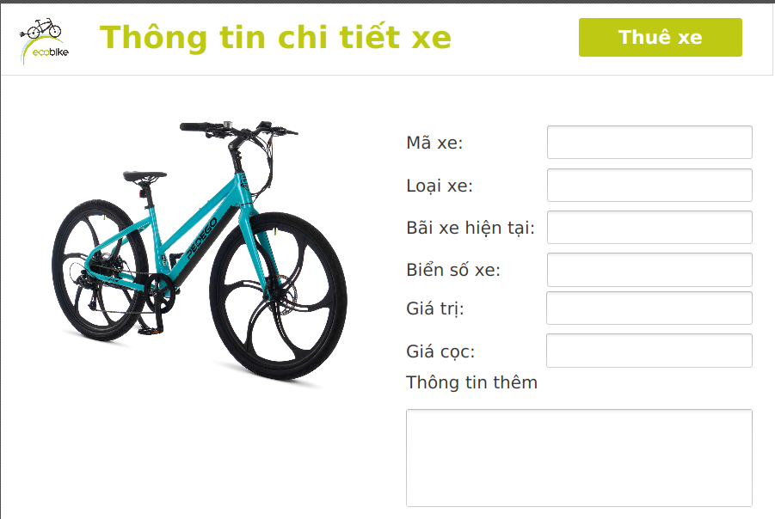

* Precondition:
* You double click one bike in Station Screen
* After you enter barcode and Confirm in Rent Bike Screen
* Function: Show information of bike
* Contain:
* Logo
* Name: Thông tin chi tiết xe
* Button “Thuê xe”: Show Deposit when you click
* Information of bike:

1. Rent BIke Screen

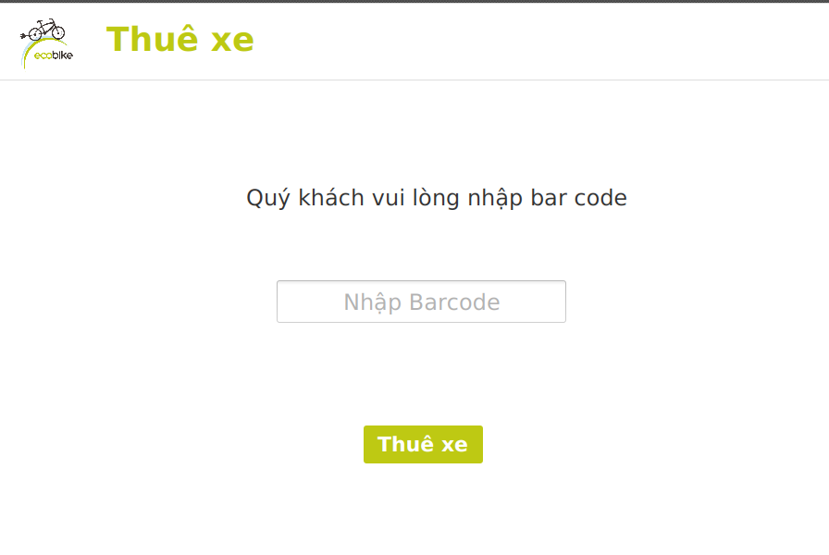

* Precondition:
* You click “Thuê xe” in Station Screen
* Function: Enter barcode of rented bike
* Contain:
* Logo
* Name: Thuê xe
* Button “Thuê xe”: Show Deposit when you click
* Barcode:

1. Deposit Screen

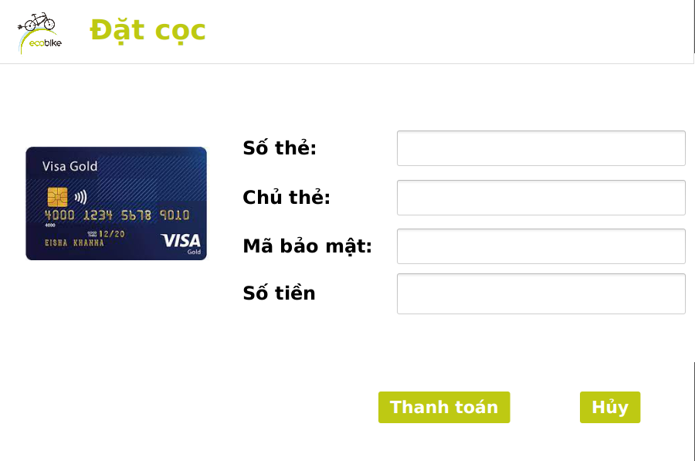

* Precondition:
* You click “Thuê xe” in Rent Bike Screen
* Function: Deposit for rented bike
* Contain:
* Logo
* Name: Đăt cọc
* Card Info:
* Card image
* Card number
* Card owner
* Code
* Amount of money
* Button “Thanh toán”
* Button “Hủy”

1. Rented Bike Info Screen

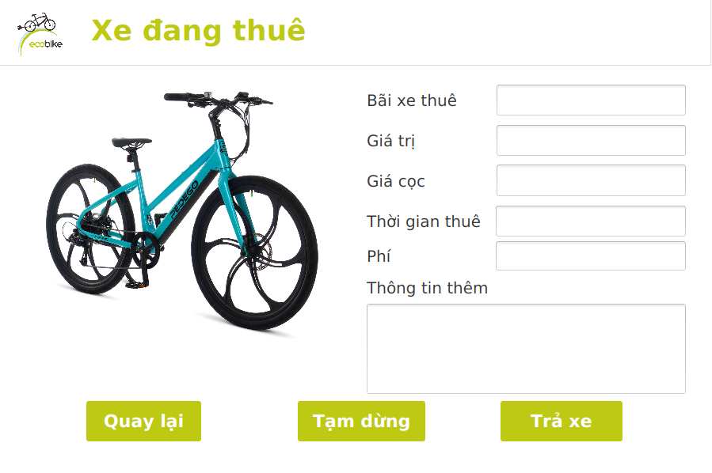

* Precondition:
* You click “Xem xe đang thuê” in Main Screen
* Function: Show information of rented bike
* Contain:
* Logo
* Name: Xe đang thuê
* Rented Bike Info:
* Button “Quay lại”
* Button “Tạm dừng”
* Button “Trả xe”: show Return BIke Screen when you click

1. Return Bike Screen

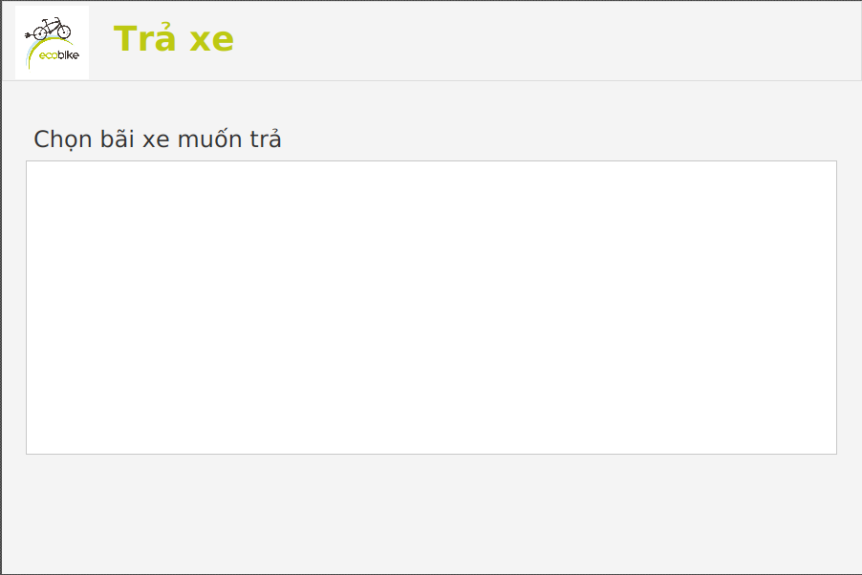

* Precondition:
* You click “Trả xe” in Rented Bike Info Screen
* Function: Choose station you want to return
* Contain:
* Logo
* Name: Trả xe
* List of available station:
* show all station by row but unavailable station information is lighter in color
* show Rented BIke Transaction Screen when you click one available station

1. Rented BIke Transaction Screen

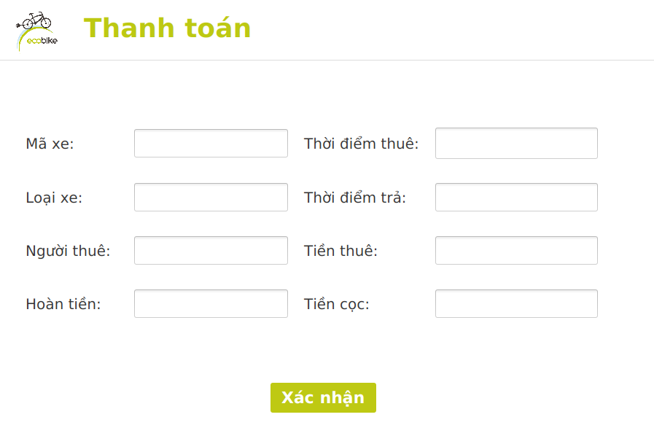

* Precondition:
* You click one available station in Return BIke Screen
* Function: Pay Order
* Contain:
* Logo
* Name: Trả xe
* Transaction Info
* Buttion “Xác nhận”